Statistical Analysis and Predictive Modeling in Agribusiness
Week 4 Task | Junior Data Analyst - Agribusiness Internship | Yuva Intern

1. Introduction
This report applies statistical analysis and a simple predictive model to one question: do farm inputs (area, fertilizer, pesticide, water) and farm characteristics (irrigation type, soil type, season, crop) explain or predict crop yield? The analysis uses the farm-level Agriculture and Farming Dataset (Kaggle), the fourth source declared in the Week 1 report (50 farms).
The main result is a null one. None of eight individual tests (four correlations, four group comparisons) found a statistically significant relationship with yield, and a multiple linear regression built from the four numeric inputs had no reliable predictive power on farms it had not seen: its cross-validated R-squared was -0.137, slightly worse than always predicting the average yield. A null result is still useful. It tells a business what it cannot conclude from this data, and this report documents why (small sample, missing variables, unstable small test sets) and what should be done next.
Rainfall and temperature, given as examples in the task brief, are not present in this dataset. The four input variables that are present (area, fertilizer, pesticide, water usage) were used instead, and weather variables are recommended as the first extension in Section 8. Every result in Section 5 comes from the Week 4 Jupyter notebook, except the power calculations (Section 5.7) and the Levene checks for soil, season and crop (Section 3.5), which are labelled as supplementary. Screenshots are rendered from the notebook's code and saved outputs.

2. Dataset Used
Name: Agriculture and Farming Dataset (agriculture_dataset.csv)
Source: Kaggle (user bhadramohit) - https://www.kaggle.com/datasets/bhadramohit/agriculture-and-farming-dataset. Licence terms should be confirmed on the Kaggle dataset page before any reuse beyond this exercise.
Role in this internship: declared as a source in the Week 1 report (the only farm-level dataset among the five sources) and used there for preliminary efficiency KPIs.
Size: 50 farms (rows) and 10 columns. No rows were removed, so the raw and analysed sizes are the same (50).
Data checks: no missing values, no duplicate rows, and 50 unique Farm_ID values (verified while preparing this report; the notebook's describe() output also shows a count of 50 for every numeric column).
Provenance: the file does not document how the values were collected, so it cannot be verified whether they are real farm measurements or simulated. This is treated as a limitation in Section 6.5.
Why not the APY dataset? the Crop-Wise Area, Production and Yield dataset used in Weeks 2 and 3 (455,359 raw rows; 450,350 after cleaning) has no input variables such as fertilizer or water, so it cannot support an input-to-yield model. It is recommended in Section 8 for a trend model instead.

Variable | Type | Role | Notes
Yield(tons) | Numeric | Target | Yield per farm, in tons
Farm_Area(acres) | Numeric | Predictor | Range 12.5 to 483.9
Fertilizer_Used(tons) | Numeric | Predictor | Range 0.50 to 9.96
Pesticide_Used(kg) | Numeric | Predictor | Range 0.14 to 4.99
Water_Usage(cubic meters) | Numeric | Predictor | Range 5,870 to 94,755 (much larger scale than the others)
Irrigation_Type | Categorical (5) | Group factor | Drip, Flood, Manual, Rain-fed, Sprinkler
Soil_Type | Categorical (5) | Group factor | Clay, Loamy, Peaty, Sandy, Silty
Season | Categorical (3) | Group factor | Kharif, Rabi, Zaid
Crop_Type | Categorical (10) | Group factor | Barley, Carrot, Cotton, Maize, Potato, Rice, Soybean, Sugarcane, Tomato, Wheat
Farm_ID | Identifier | Not used | Anonymous code (F001 to F050)

3. Methodology

3.1 Variable selection and hypotheses
The target variable is Yield(tons). The four numeric inputs were chosen because agronomy gives a plausible reason for each to influence yield: more land can mean more total harvest, fertilizer and water supply plant nutrition, and pesticide limits crop loss. The four categorical variables were tested as group factors. The expectation (positive effects of area, fertilizer and water) was written down before testing, but every test is two-sided, so an unexpected result would be detected in either direction.

Test | Null hypothesis (H0) | Alternative (H1)
Pearson correlation (each of 4 inputs vs yield) | The correlation between the input and yield is zero | The correlation is not zero
One-way ANOVA (each of 4 groupings) | All group mean yields are equal | At least one group mean differs
Regression, overall F-test | All four regression coefficients are zero | At least one coefficient is non-zero
Regression, t-test per coefficient | The coefficient is zero (no effect, other inputs held fixed) | The coefficient is not zero
Predictive check (train/test and cross-validation) | Out-of-sample R-squared is 0 or lower (no better than guessing the average) | Out-of-sample R-squared is above 0
Decision rule: significance level alpha = 0.05; H0 is rejected only if p < 0.05. When p is above 0.05 the wording used is 'fail to reject H0', which means the data cannot show an effect, not that the effect is proven absent. The predictive check is judged descriptively across repeated splits, not by a single formal test.

3.2 Statistical tests chosen and why
- Pearson correlation (scipy pearsonr): measures the strength and direction of a straight-line association between two numeric variables (r from -1 to +1) and returns its p-value. It is the natural first screen for each numeric input.
- One-way ANOVA (scipy f_oneway): compares mean yield across three or more groups in a single test. It was preferred over many pairwise t-tests because repeating t-tests inflates the chance of a false positive.
- Levene's test: checks the ANOVA assumption that groups have similar spread (equal variances).
- Ordinary least squares (OLS) regression (statsmodels): uses all numeric inputs together, estimates each input's effect with the others held fixed, and reports an overall F-test, coefficient t-tests, confidence intervals, R-squared and adjusted R-squared.
- MAE (mean absolute error) and out-of-sample R-squared (scikit-learn): measure prediction quality on farms the model did not see. MAE is in tons, so it can be compared directly with the average yield.

3.3 The predictive model
Yield = b0 + b1*Farm_Area + b2*Fertilizer + b3*Pesticide + b4*Water + error
Multiple linear regression was chosen because it is interpretable (each coefficient is a plain-language effect), uses few parameters (five), and suits a small dataset. The categorical variables were deliberately left out of the regression: coding them as indicator variables would add 19 parameters (4 for irrigation, 4 for soil, 2 for season, 9 for crop) to a model fitted on 50 farms, which would mostly fit noise. More flexible machine-learning models were not used for the same reason: with 50 rows there is not enough data to learn complex patterns reliably.

3.4 Evaluation design
- Baseline: a forecaster that always predicts the average yield. A useful model must beat it (out-of-sample R-squared above 0, MAE below the baseline MAE).
- Train/test split: 80% of farms (40) build the model and 20% (10) are hidden to test it. Repeated with five random seeds (0, 1, 2, 3, 42), because a 10-farm test set is very sensitive to which farms are picked.
- 5-fold cross-validation: the 50 farms are shuffled and divided into five groups of 10. Each group is the test set once while the model is built on the other 40, so every farm is tested exactly once.

3.5 Model assumptions and how each was checked
Assumption | Why it matters | Check | Result
Linearity | The model draws straight-line relationships | Residuals vs predicted plot | No curve visible: satisfied
Constant spread of errors | Unequal spread distorts standard errors and p-values | Same residual plot | No funnel shape: satisfied
Independent errors | Related errors make p-values too optimistic | Durbin-Watson | 1.913, near 2. Farms are not time-ordered, so this test has limited meaning, and shared local weather cannot be ruled out
Roughly normal errors | Needed for valid p-values and confidence intervals in small samples | Jarque-Bera and Omnibus tests | Jarque-Bera p = 0.305 (acceptable); Omnibus p = 0.039 (mild concern). Both tests have low power at n = 50
No strong overlap between inputs | Overlapping inputs make coefficients unstable | Variance inflation factor (VIF) | 1.02 to 1.07: satisfied. The condition-number warning (2.56e+05) comes from water being measured on a much larger scale
ANOVA: equal group variances | Unequal spread weakens ANOVA | Levene's test | Irrigation p = 0.755 (in notebook); soil 0.948, season 0.793, crop 0.957 (supplementary check)
ANOVA: normal yields within groups | Needed for the F-test to be exact | Cannot be checked reliably | Groups have only 3 to 23 farms; treated as a limitation

3.6 Theoretical walkthrough of the data-processing pipeline
The following sequence is how data moves through this framework. Steps 1 to 4 and 6 to 10 were carried out in this analysis (Section 5); step 5 is the theoretical treatment of categorical variables and was not used in the final model, for the reason given in Section 3.3.
1. Ingest and validate : load CSV; check shape, types, missing, duplicates
2. Define variables : target = Yield; inputs = area, fertilizer,
pesticide, water
3. Explore : summary statistics; input-vs-yield correlations
4. Test hypotheses : Pearson (numeric); ANOVA + Levene (categorical)
5. Encode categoricals : (theory) one-hot encode, drop one level each;
not used: 19 extra parameters for 50 rows
6. Split / cross-validate : 80/20 split (5 seeds) and 5-fold CV
7. Fit OLS : estimate coefficients on training farms only
8. Predict : predict yield for the held-out farms
9. Compare to baseline : R-squared, MAE vs always-guess-the-mean
10. Diagnose, interpret : residual plot, VIF, normality; decide the use

4. Theoretical Underpinnings
- Least squares: OLS chooses the coefficients that minimise the sum of squared residuals (real yield minus predicted yield). Its standard errors, t-tests and F-test are only valid if the assumptions in Section 3.5 hold.
- Pearson r: the covariance of two variables divided by the product of their standard deviations. It captures straight-line association only, so a curved relationship could produce r near zero.
- ANOVA and the F ratio: ANOVA splits total variation into variation between group means and variation within groups. F is the ratio of the two. An F near 1 means group means differ no more than random variation within groups would produce.
- The p-value: the probability of a result at least as extreme as the one observed if H0 were true. It is not the probability that H0 is true.
- Adjusted R-squared: R-squared never falls when predictors are added, even useless ones. Adjusted R-squared subtracts a penalty for each added predictor, and can be negative, as it is here (-0.036).
- Generalisation and cross-validation: R-squared on the farms used to build the model is optimistic, because the model has partly fitted their noise. Honest performance is measured on held-out farms, and averaging over several held-out sets (cross-validation) reduces the luck of any one split.
- Statistical power: the chance a test detects an effect that is really there. With few observations only large effects can be detected (quantified in Section 5.7), so a non-significant result in a small sample is weak evidence of no effect.

5. Analysis and Results

5.1 Descriptive summary
Variable (n = 50 farms) | Mean | Std. dev. | Min | Max
Yield (tons) | 27.06 | 13.35 | 3.86 | 48.02
Farm area (acres) | 254.96 | 139.42 | 12.50 | 483.88
Fertilizer (tons) | 4.91 | 2.73 | 0.50 | 9.96
Pesticide (kg) | 2.40 | 1.44 | 0.14 | 4.99
Water usage (cubic meters) | 56,724.30 | 27,264.99 | 5,869.75 | 94,754.73
Each input is spread across a wide range, so there is variation for the model to use. Yield itself varies widely (standard deviation 13.35 against a mean of 27.06), which is the variation the inputs would need to explain.

5.2 Correlation analysis
Input vs yield | r | p-value | Decision at alpha = 0.05
Farm area (acres) | 0.153 | 0.288 | Fail to reject H0
Fertilizer (tons) | 0.045 | 0.756 | Fail to reject H0
Pesticide (kg) | -0.090 | 0.532 | Fail to reject H0
Water usage (cubic meters) | 0.108 | 0.454 | Fail to reject H0
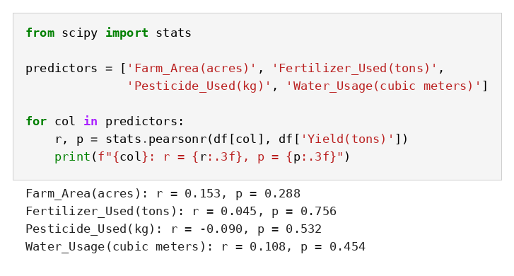
Figure 1: Pearson correlation of each input with yield (Week 4 notebook).
All four correlations are weak (r between -0.09 and 0.15) and none is significant. At n = 50 a correlation must reach roughly |r| = 0.28 to be significant at the 5% level, and the strongest observed (area, r = 0.153) is well short of that.

5.3 Group comparisons (one-way ANOVA)
Grouping | Groups (farms per group) | F | p | Decision
Irrigation type | Drip 15, Flood 13, Manual 6, Rain-fed 7, Sprinkler 9 | 1.413 | 0.245 | Fail to reject H0
Soil type | Clay 14, Loamy 11, Peaty 4, Sandy 11, Silty 10 | 0.341 | 0.849 | Fail to reject H0
Season | Kharif 16, Rabi 11, Zaid 23 | 0.230 | 0.796 | Fail to reject H0
Crop type | Barley 7, Carrot 4, Cotton 7, Maize 3, Potato 4, Rice 5, Soybean 5, Sugarcane 5, Tomato 6, Wheat 4 | 0.758 | 0.655 | Fail to reject H0
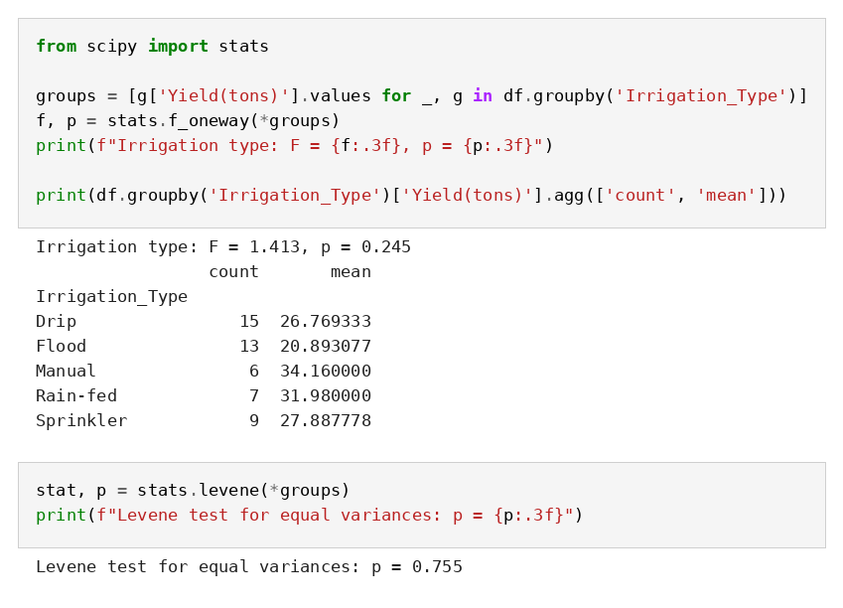
Figure 2: ANOVA of yield by irrigation type, with Levene's test for equal variances.
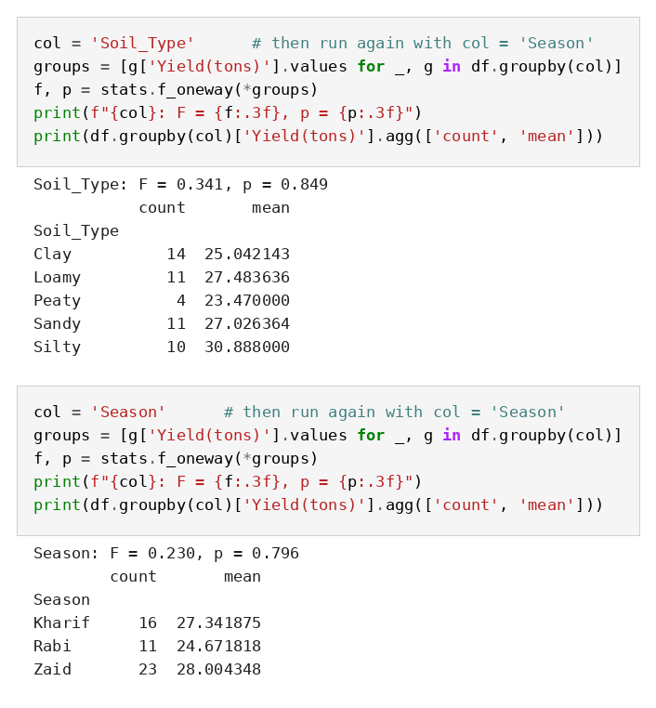
Figure 3: ANOVA of yield by soil type and by season.
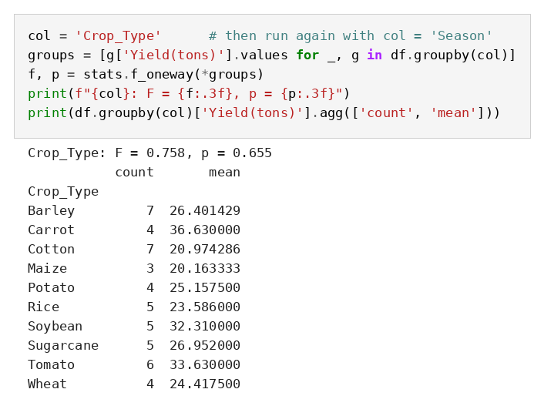
Figure 4: ANOVA of yield by crop type.
No grouping is significant. The group averages do look different (for example Flood irrigation 20.9 tons versus Manual irrigation 34.2 tons; Maize 20.2 versus Carrot 36.6), but these averages rest on very few farms (Manual 6, Maize 3, Peaty soil 4), and gaps of that size are what random variation produces in samples this small. This formalises the concern raised in Week 1, where Manual irrigation appeared to have the highest average yield.

5.4 Multiple linear regression
Term | Coefficient | Std. error | p-value | 95% confidence interval
Intercept | 20.2482 | 7.810 | 0.013 | 4.517 to 35.979
Farm area (per acre) | 0.0146 | 0.014 | 0.310 | -0.014 to 0.043
Fertilizer (per ton) | 0.2909 | 0.718 | 0.687 | -1.156 to 1.738
Pesticide (per kg) | -0.8228 | 1.393 | 0.558 | -3.629 to 1.983
Water (per cubic meter) | 0.0000640 | 0.0000725 | 0.382 | -0.0000821 to about 0.000
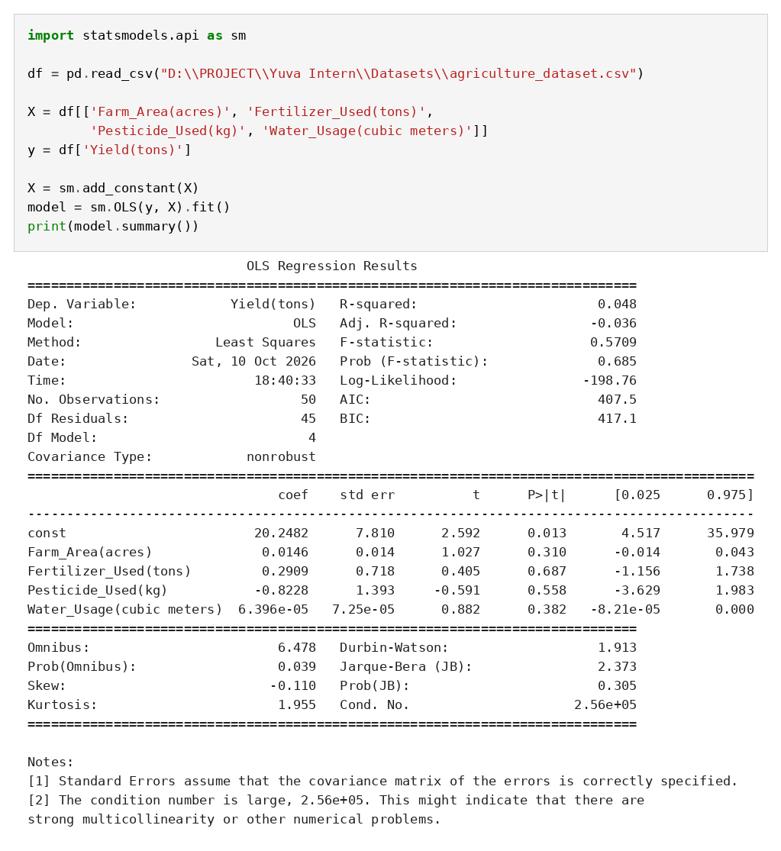
Figure 5: OLS regression output for yield on the four numeric inputs.
- Overall fit: R-squared is 0.048, so the four inputs explain about 4.8% of the variation in yield. Adjusted R-squared is -0.036, meaning that once the penalty for using four predictors is applied, the model explains nothing.
- Overall F-test: F = 0.5709, p = 0.685. H0 (all coefficients are zero) is not rejected.
- Individual coefficients: none is significant (p from 0.310 to 0.687). Every confidence interval includes zero. For fertilizer, the estimate is +0.29 tons of yield per extra ton, but the interval runs from -1.16 to +1.74, so even the direction of the effect is unknown. The water coefficient looks tiny only because water is measured in very large units; per 1,000 cubic meters it is about 0.064 tons, and it is equally non-significant.
- The intercept: its p-value (0.013) only says the baseline yield is not zero, which has no practical meaning here.

5.5 Predictive performance on unseen farms
Evaluation | Result
Single split (seed 42): test R-squared / MAE | 0.097 / 10.31 tons (baseline MAE 11.20 tons)
Repeated splits, test R-squared for seeds 0, 1, 2, 3, 42 | -0.131, -0.054, -0.724, -0.425, 0.097
5-fold cross-validation, R-squared per fold | 0.097, -0.088, -0.020, -0.539, -0.135
5-fold cross-validation, average R-squared | -0.137
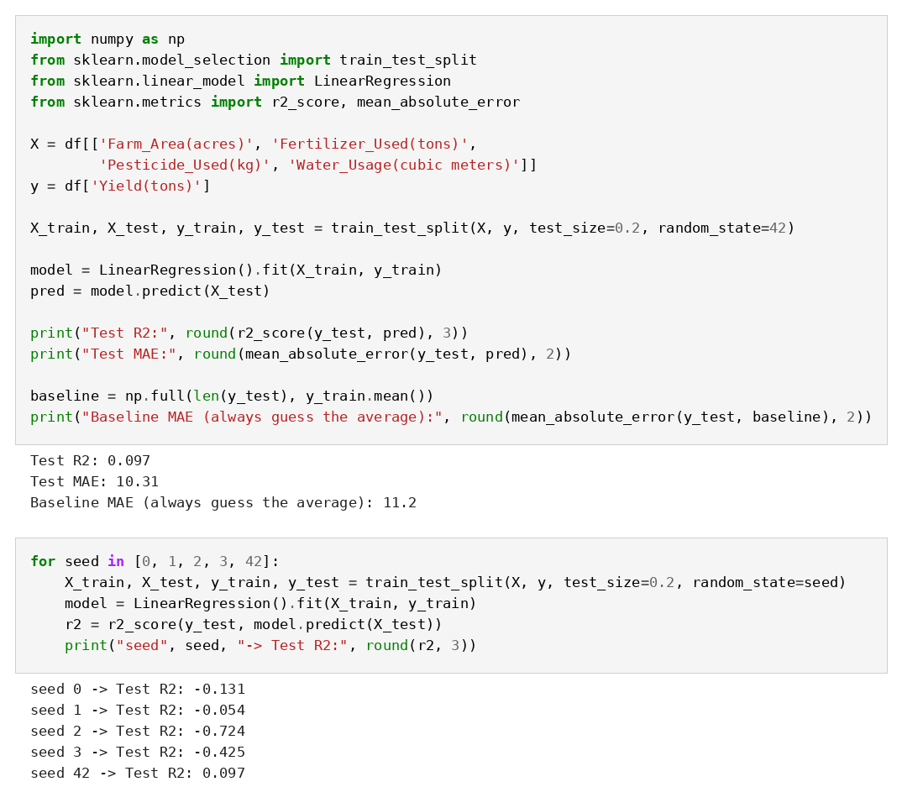
Figure 6: Train/test split (seed 42) and the repeated-seed experiment.
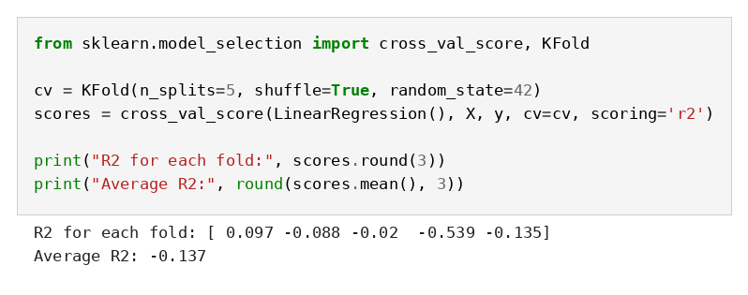
Figure 7: 5-fold cross-validation scores.
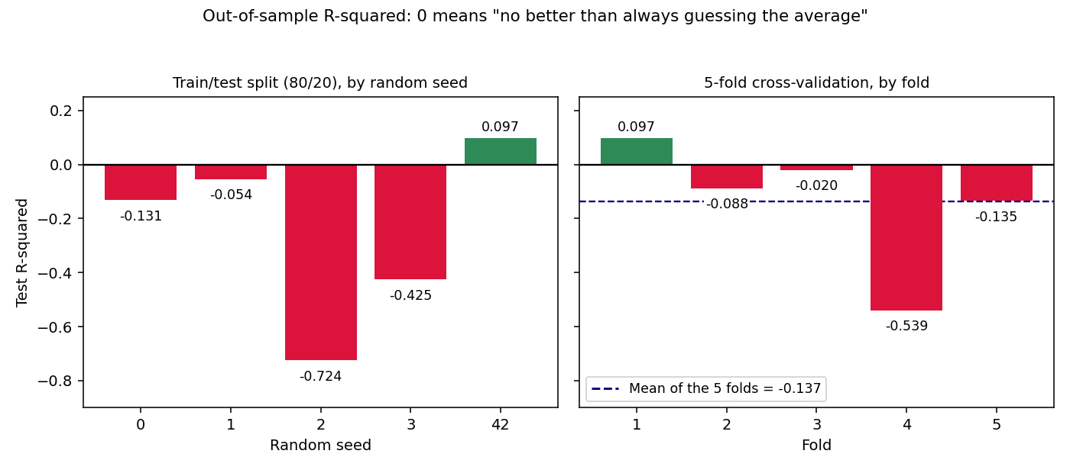
Figure 8: Out-of-sample R-squared by random seed and by fold, from the notebook outputs. Bars below zero mean the model did worse than always predicting the average yield.
The single split with seed 42 looked like a small success (R-squared 0.097; MAE 10.31 tons against a baseline of 11.20, an improvement of 0.89 tons on a mean yield of 27.06). Repeating the split exposed that result as luck: four of five seeds gave a negative R-squared, down to -0.724, and cross-validation averaged -0.137. The test set contains only 10 farms, so one unusual farm can swing the score. Even the seed-42 MAE of 10.31 tons is about 38% of the average yield, an error too large to guide decisions. Reporting only seed 42 would have been cherry-picking; all five seeds and all five folds are therefore reported.

5.6 Assumption checks
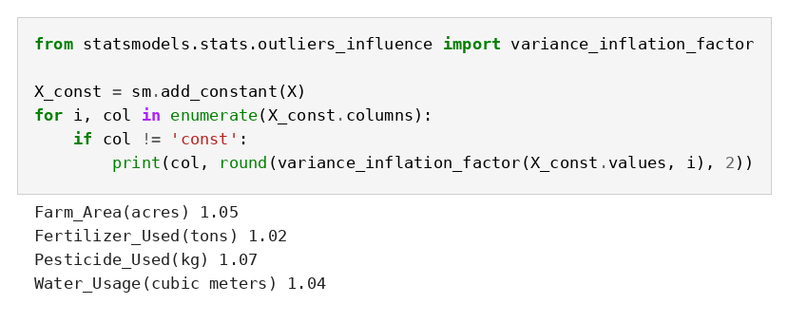
Figure 9: Variance inflation factors for the four inputs.
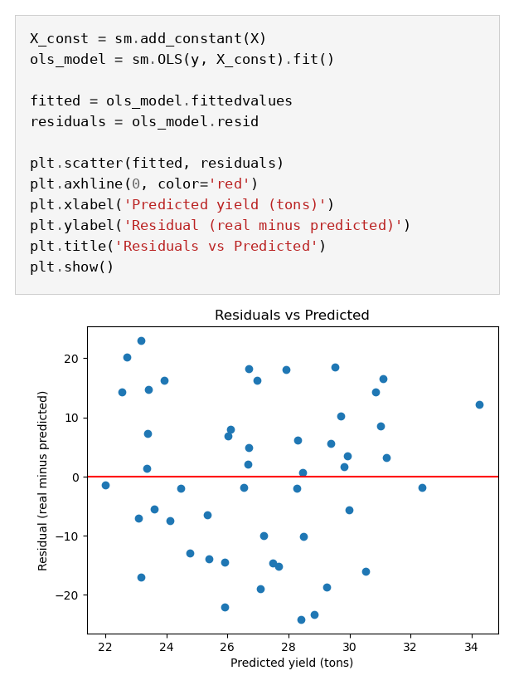
Figure 10: Residuals versus predicted yield (plot saved in the notebook).
VIF values are 1.02 to 1.07, so the inputs do not overlap and the large condition number in the regression output is a scaling effect, not real multicollinearity. The residual plot is a shapeless cloud with no curve or funnel, so linearity and constant spread look acceptable. Two features of the plot matter for interpretation, though. Predicted yields only range from about 22 to 34 tons while real yields range from about 4 to 48, so the model is effectively saying 'roughly average' for every farm, and residuals reach about 24 tons. A clean residual plot therefore does not mean the model is good: the model is not missing a pattern in the shape, it is missing information.

5.7 Statistical power (supplementary calculation)
These figures are standard formulas (Fisher z-transformation, two-sided alpha = 0.05) calculated while preparing this report; they are not outputs of the notebook.
Quantity | Value
Smallest |r| that is significant at n = 50 | about 0.28
Smallest |r| detectable with 80% power at n = 50 | about 0.39
Farms needed to detect r = 0.30 with 80% power | about 85
Farms needed to detect r = 0.15 with 80% power | about 347
Chance of at least one false positive across the 8 individual tests (4 correlations, 4 ANOVAs) if no real effects exist | about 34% (1 - 0.95^8); Bonferroni-adjusted threshold 0.05 / 8 = 0.00625
With 50 farms, only moderate-to-strong effects (|r| of about 0.4 or more) could be reliably detected. A real but weak relationship, of the kind that is common between single farm inputs and yield, would very likely be missed. This is why the non-significant results are described as 'could not be shown', not 'does not exist'.

6. Discussion

6.1 Interpretation: six methods, one answer
Method | Result | Meaning
Correlation (4 inputs) | All p above 0.28 | No input tracks yield
ANOVA (4 groupings) | All p above 0.24 | No group differences detected
Regression F-test | p = 0.685 | Model no better than the average
Adjusted R-squared | -0.036 | Inputs add nothing
Train/test, 5 seeds | 4 of 5 negative | Not reliable on unseen farms
5-fold cross-validation | Average -0.137 | Worse than guessing the average
Several different methods agree, so the null result is not a coding error; it is a property of this dataset. What it does not show is that fertilizer, water, pesticide or irrigation have no effect on real farms. It shows that these 50 records cannot demonstrate one.

6.2 Business implications
Finding | Business implication
No input is significantly related to yield | This dataset should not be used to justify raising or cutting fertilizer, pesticide or water budgets. A decision of that kind needs stronger evidence.
Irrigation group gaps (Flood 20.9 vs Manual 34.2 tons) are not significant | No basis in this data for recommending a switch of irrigation method. The Manual group has only 6 farms.
Out-of-sample R-squared is about zero or negative | The model should not be deployed as a yield forecast. Planning with the average yield (27.1 tons) is about as accurate.
Test scores swing from +0.10 to -0.72 by split | Any model reported on a single small test split should be questioned. Validation should use repeated splits or cross-validation.
Power analysis: about 85 to 347 farms needed | The most valuable next investment is better data (more farms plus weather and soil measurements), not a more complex model.

6.3 Potential outcomes
- If the model were used to recommend inputs: its predictions cluster between about 22 and 34 tons while real yields span 4 to 48 tons, and the typical error is about 10 tons (38% of the average). Recommendations would be indistinguishable from 'expect an average harvest', and spending on inputs could be misallocated on the false impression that the data supports it.
- If the null result were misread as 'inputs do not matter': a farm advisory service might discourage inputs that do matter on real farms. The correct reading is 'not demonstrated with this data'.
- If only the seed-42 result had been reported: an R-squared of 0.097 would have been presented as a working model, creating false confidence. Reporting all splits prevents this.
- Positive outcome of the honest result: time and money are not spent building or deploying a model that does not work, and data-collection effort is redirected to the missing drivers of yield.

6.4 Limitations and reliability of the model
- Sample size and power. With 50 farms only effects of about |r| >= 0.39 can be detected reliably. Weak real relationships would be missed, so non-significant results are inconclusive rather than proof of no effect.
- Unstable evaluation. A 10-farm test set produced R-squared values from +0.097 to -0.724 depending on the shuffle. Even cross-validation, with folds of 10 farms, has wide uncertainty; its mean (-0.137) should be read as 'around zero or worse', not as a precise number.
- Multiple comparisons. Eight individual tests were run, giving about a 34% chance of at least one false positive if no real effects existed. No test was significant, so this did not distort the conclusions, but any future significant result from this data would need adjustment (for example Bonferroni, 0.05 / 8 = 0.00625).
- Missing variables. Rainfall, temperature, soil nutrients, sowing date and crop variety are not in the data, and they are likely to be major drivers of yield. A model cannot explain variation from variables it has not been given.
- Mixed crops in a small sample. Ten crop types are pooled, with 3 to 7 farms each. Week 3 showed that statistics pooled across crops can be misleading because crops operate on different scales, but with so few farms per crop a separate model per crop is impossible.
- Categorical variables excluded from the regression. Irrigation, soil, season and crop were tested one at a time but not entered into the regression, because the extra 19 parameters would overfit 50 rows. Interactions (for example fertilizer effects that depend on soil type) were not examined for the same reason.
- Linearity and model form. A straight-line model was used. Real input-response relationships often level off (diminishing returns). The residual plot shows no obvious curve, but with this much noise a curve would be hard to see.
- Independence and generalisation. Farms may share weather, region or advisers, which would violate the independence assumption; there is no location or date information to check. Results apply to this sample only and cannot be assumed to hold for other regions or years.
- Unknown data provenance. It cannot be verified whether the values are real measurements or simulated. If they are simulated without built-in relationships, the absence of any signal would be expected.

6.5 Ethical considerations
- Honest reporting of null and unstable results: choosing the best-looking seed, or running more and more variables until something is significant (p-hacking), would mislead decision-makers. The analysis plan (which tests, which threshold) was fixed beforehand, and all results are reported, including the unfavourable ones.
- Provenance and consent: if these are real farm records, it is unknown whether the farmers consented to this secondary analysis. Farm_ID is an anonymous code, so re-identification risk looks low, but the collection method should be confirmed and the Kaggle licence checked.
- Risk of harmful advice: yield predictions and input recommendations can affect farmers' livelihoods. A model with no demonstrated skill must not be used for advice, and the limits of the evidence should be stated clearly to anyone who reads these results.
- Stigmatising small groups: labelling a group of 3 to 6 farms (for example Manual irrigation or Peaty soil) as better or worse on the basis of noisy averages could unfairly characterise the farmers involved. Group results are therefore reported with their sample sizes and as non-significant.

7. Challenges Faced and Strategies Used

Analytical challenges
- A null result everywhere. Every test returned a non-significant result, which creates a temptation to keep searching for something significant. Strategy: hypotheses and the significance level were fixed in advance, all tests were reported, and the multiple-comparisons risk was quantified (about 34%).
- A misleadingly good first result. The first train/test split (seed 42) gave R-squared = 0.097 and an MAE below the baseline, which looked like success. Strategy: repeating the split with four more seeds, then 5-fold cross-validation, showed that this was the one favourable split and that the true out-of-sample performance is around zero or negative.
- Interpreting 'good-looking' diagnostics. The residual plot and VIF values looked clean, yet the model had no predictive skill. Strategy: separating 'assumptions hold' (the plot is acceptable) from 'the model is useful' (it is not), and explaining that the model is missing information rather than shape.
- Very small groups. Some groups have 3 to 6 farms (Maize 3, Peaty soil 4, Manual irrigation 6). Strategy: group sizes were shown beside every average, and apparent differences were treated as unreliable when the ANOVA was not significant.

Technical challenges
- A variable-name clash. Drawing the residual plot raised AttributeError: 'LinearRegression' object has no attribute 'fittedvalues'. The name 'model' had first held the statsmodels regression and was later overwritten by the scikit-learn model in the train/test step. Strategy: the statsmodels model was refitted under a separate name (ols_model), and distinct names are now used for each library's model.
- A condition-number warning. The regression summary warned that the condition number was large (2.56e+05), which can signal multicollinearity. Strategy: instead of ignoring or accepting the warning, VIF was calculated (1.02 to 1.07), showing the warning came from water usage being measured on a much larger scale than the other inputs.

8. Recommendations for Further Analysis
1. Collect the missing drivers of yield. Add rainfall and temperature (for example from the IMD source identified in Week 1), soil nutrient tests (nitrogen, phosphorus, potassium, pH) and sowing dates for each farm. Without these, no model on this data can explain much.
2. Increase the number of farms. Target at least 85 farms to detect a moderate correlation (r = 0.30) and about 350 to detect a weak one (r = 0.15) with 80% power. Where each crop needs its own model, aim for at least 30 farms per crop.
3. Use the declared APY dataset for a trend model. It has the sample size this dataset lacks (450,350 rows after Week 2 cleaning). A regression of Wheat yield on year, with state as a grouping factor, would test formally whether the +43.2% Wheat improvement observed in Week 3 is a statistically significant trend, with a confidence interval for the yearly gain.
4. Model each crop separately or use a multilevel model. Once enough farms per crop exist, fit per-crop regressions, or a mixed-effects model with crop as a random effect so that crops share information without being forced onto one scale.
5. Compare model types fairly. With more variables and farms, compare regularised regression (ridge or lasso) and a tree-based model such as a random forest against the 'always guess the average' baseline, using repeated cross-validation and reporting every fold.
6. Fix the analysis plan in advance. Write down hypotheses, tests and the multiple-comparison correction before looking at new data, and report effect sizes with confidence intervals alongside p-values.
7. Document data provenance. Before reusing the Kaggle dataset, confirm how it was collected, whether it is real or simulated, and what licence applies.

9. Conclusion
This task applied correlation analysis, one-way ANOVA with a variance check, multiple linear regression, and train/test and cross-validation evaluation to the 50-farm Kaggle dataset, with the hypotheses, assumptions and pipeline documented. Six different methods agree: farm area, fertilizer, pesticide, water usage, irrigation type, soil type, season and crop type show no statistically detectable relationship with yield, and the regression has no reliable predictive power (cross-validated R-squared -0.137; the apparent success of one split, R-squared 0.097, was luck). The model's assumptions are largely acceptable, so the failure is not one of technique: the dataset is too small and lacks the variables most likely to drive yield. The business conclusion is cautious. These results should not be used to change input budgets or to forecast yield, and the highest-value next steps are more farms, weather and soil measurements, and a trend model on the much larger APY dataset. Reporting an honest null result, with its limits, is the correct outcome of a sound analysis, not a failed one.

